|  |
| --- |
| *FLORIDA INTERNATIONAL UNIVERSITY*  School of Computing and Information Sciences  CIS 4911 Senior Capstone Project |
| **Smart Systems for Occupancy and Building Energy Control (SSOBEC)** |
| Installation Guide |
|  |
|  |
| **Instructor**: Dr. Masoud Sadjadi  **Mentor**: Dr. Leonardo Bobadilla  **Mentor:** Dr. Ali Mostafavi    01/23/2015  *Group Member:*  Maria Eugenia Presa Reyes  Dalaidis Hidalgo Arencibia |

**Introduction**:

The purpose of this document is to guide you through the steps needed to be taken to do installation, setup and update for a development environment in order to extend this system.

**Perquisites**:

**Software required to run this project**:

1. Windows 7 – Windows 8.1, Mac OS, Ubuntu 14.04 LTS

2. Android Studio

**Development environment applications**:

1. Apache

2. MySQL

3. PHP5

**Installation**:

Clone the repository for Smart Systems for Occupancy and Building Energy Control on GitHub:

<https://github.com/FIU-SCIS-Senior-Project-2015-Spring/Smart-Systems-for-Occupancy-and-Building-Energy-Control>

**Setting up the database in the server**:

Install LAMP stack running the following commands.

sudo apt-get update

sudo apt-get install lamp-server^

When going to your domain you should see the following page.

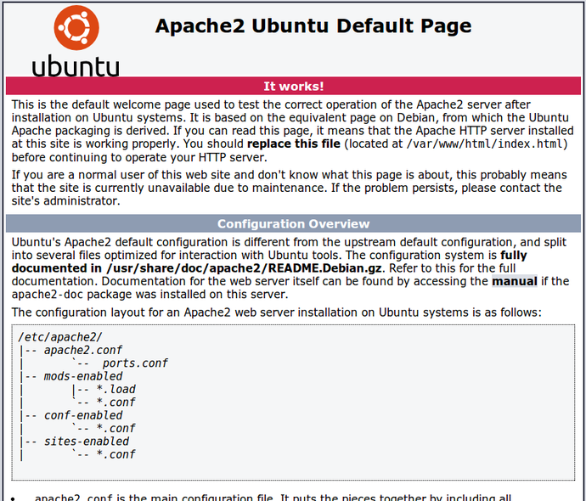

Install Phpmyadmin running the following commands.

sudo apt-get install phpmyadmin

sudo dpkg-reconfigure -plow Phpmyadmin.

sudo service apache2 reload

Got to <http://yourserver.com/phpmyadmin> to confirm

In the ‘Database’ directory you will find an SQL file with all queries to create the tables. Copy the queries and run it in Phpmyadmin.

The Database tables are:

* lighting_energy_performance: A statistical calculation of the lighting energy performance of a zone.
* plugload_energy_performance: A statistical calculation of the plug load energy performance of a zone.
* region_authority: Which users can see which zones. It links the zone id and the user id.
* testing_ac_prediction: A table that serves to test the prediction of air conditioning energy consumption.
* user: Information of the user’s account.
* zone_description: Information of the zone.
* zone_lighting: Information of the lighting energy performance in a zone.
* zone_occupancy: Information of the occupancy behavior in a zone.
* zone_plugload: Information of the plug load energy performance in a zone.
* zone_temperature: Information of the temperature behavior in a zone.

Copy the php files found in the PHP directory and transfer them to /var/www/html. These php files serve to give access to the database and retrieve information from the database using MySQL queries.

**Open the Project in Android Studio:**

Download Android Studio from: <http://developer.android.com/sdk/index.html>

Once Android Studio is installed on your computer, be sure to download the SDK tools needed to develop for the android device <http://developer.android.com/sdk/installing/adding-packages.html>. If the Android device you are going to be using for verification of the code is of API 20, then you need to download the SDK package for API 20. Open the project in Android Studio.

You are now ready to start development for Smart Systems for Occupancy and Building Energy Control.